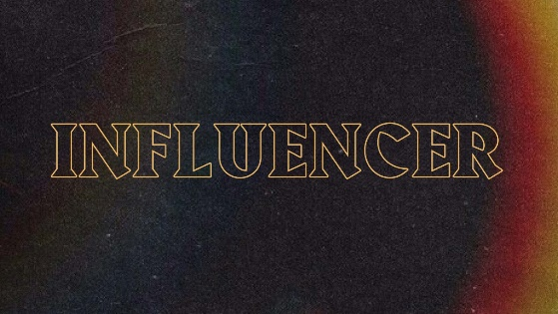

**Influencer – Week 2**

**LIFE/INTRO QUESTIONS (CHOOSE 1 OR 2)**

* Who are some of your biggest influences in your life? Could be family, friends, or even someone famous.
* Why are those people such big influences in your life? Give examples.

**CONNECTION QUESTION**

* Where do you see yourself in the future? Job, family, finances? Are the people in your life supporting you in a way so that you can obtain the future that you want or are they dragging you away from that?

**Sermon in a Sentence**

* Who is leading you and where are they leading you to?

**SCRIPTURE**

* Proverbs 11:14 “Where there is no guidance, a people falls, but in an abundance of counselors there is safety.”
* What is Jesus saying in this scripture?

**DISCUSSION QUESTIONS**

* How do you personally pick out friends? Are you pursuing good friends or do you just let anyone be your friend?
* Who are your biggest mentors? Are these mentors leading you to your greatness or are they leading you down the wrong path?
* Are you following the filling first? Remind them that following the filling means following the Holy Spirit and they are to follow God first over all other people because He is the one to bring true fruits and blessings to them.

**LIFE APPLICATION**

We want students walking away with 1 or 2 things they are going to do SOON to apply what they discussed.

* Which area in your life do you need to begin following a great influencer in? School, work, home life, friend groups?

**TAKE IT OUT**

* Close small group out with prayer requests.
* After prayer, remind them of THE WEEKEND and any upcoming group events!